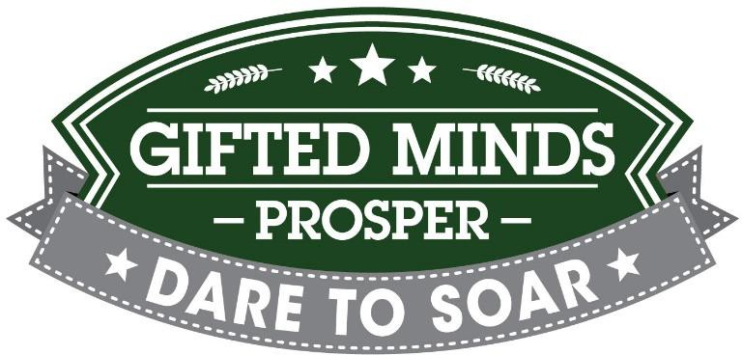

Gifted Minds Prosper – bd meeting 01-22-2025 at 9.30 am

Shannon Wentz-President

~~Liz Yip- First VP~~

Courtney Stewart Van Dyke- Treasurer

Astine Alaverdyan – Secretary

Amber Correll

Tina Marr

Eileen Curtayne

Sushma Krishnamurthy (SK)- for a portion of the meeting

Amanda Valadez

Treasurer Update. Courtney reported that as of December 31, 2024 the checkbook balance is $12,611.88. The monthly financial report has been discussed and approved by the Board.

Second VP Candidacy. Shannyn reported that Nidhi Jaiswal, 2nd VP, tendered her resignation effective as of January 22, 2025. Shannyn proposed Eileen Curtayne’s candidacy for the 2nd VP to continue the existing terms through its expiration date. Shannyn approved the motion and Courtney seconded the motion. Eileen Curtayne was elected as a Second VP through the expiration of the current term.

Committee Chair Update. Tina updated the Board that the current cost to rent the same space for the Camp Fair is $1,200 and she is looking for alterative space options. There is an option to use space with Anderlin Arts who offered a discounted rate for the space and also increase table charges from $100/table to $150/table.

VP Program Update. Liz sent an email update regarding the chess club update suggesting that due to the participation and interest last year, we divide the group from K-4th grades and 5-8 grades. More discussions ensued and further discussion will happen during the next meeting.

Mentorship Connection. At this junction, Sushma Krishnamurthy (SK) attended the meeting and discussed with the board mentorship opportunities that her platform offers. SK offered GMP to utilize the platform at a discounted rate. The Board discussed the opportunity, risks and obligations and advised SK that will consider the offer. SK left the meeting at that point.

Next Board Meeting. Next board meeting is set for February 5, 2025, location TBD.

Meeting Adjourned at 10:30 am.